HSEM assistance with the RA process is available. Please allow a 5 day turnaround for feedback
Risk Assessment Name: Working alone or in isolation on fieldwork

Risk Assessment Description: |  | Location/Date:
Risk Assessment Owner (Person developing RA)  Name:………………………………………………………………………..  Position:……………………………………………………………………..  Signature:……………………………………………………………………  Date: / /20 | Risk Assessment Approver (Person authorising RA)  Name:………………………………………………………………………..  Position:……………………………………………………………………..  Signature:……………………………………………………………………  Date: / /20
Documentation: Certificates, Permits, relevant Australian Standards and other documents applicable to this activity

IDENTIFY | ASSESS |  |  |  | CONTROL
Step 1  Enter risk description | Step 2  Select hierarchy of control and describe the existing control | Step 3  Level of risk with existing controls |  |  | Step 4  Select hierarchy of control and describe your proposed treatment | Step 5  Who is responsible and due date |  | Step 6  Level of risk after treatment
Risk Description (Hazard) | Existing Controls  Hierarchy of Control  - Eliminate, eg: eliminate task, remove hazard  - Substitute eg: replace with less hazardous process  - Isolate eg: enclosures, restricted access  - Engineering eg: guarding, separation, redesign  - Administrative eg: SWP, training, schedule  - Personal Protective Equipment (PPE) eg: gloves | Consequence | Likelihood | Risk Score | New/Additional Controls  Select the hierarchy of control and describe your proposed treatment | Who is responsible for implementing the control(s) | Due Date | Consequence | Likelihood | Risk Score
Communications difficulties related to distance and service availability |  |  |  |  | Mobile phone coverage available  Satellite phone to be carried at all times  Communications plan in place  Safezone coverage arranged for area prior to commencement of the trip (if required)  All participants instructed how to use Safezone for domestic or  International SOS for international contact as part of pre-briefing/induction
Lack of emergency services access |  |  |  |  | Suitable number of trained first aiders present  Suitable number persons trained to use fire extinguisher present  Suitable first aid kits available  Suitable fire extinguisher present in vehicle  Local Police and emergency services notified of the trip/activity  Local Police and emergency services phone numbers programmed into mobile and Satellite phones prior to the commencement of the trip/activity  Epirb carried at all times  Closest RFDS runway identified
Lack of ability to be directly supervised |  |  |  |  | Participants suitably trained prior to commencement of the trip/activity  Set areas identified in which participants can complete activities  Communications plan in place and activated every time when working alone or in isolation  Emergency kits, first aid and communications equipment to be taken every time when working alone or in isolation
Travel Risks  - Remote driving |  |  |  |  | Select the appropriate vehicle type for the journey;  Check the predicted weather and the road conditions for the duration of the journey;  Ensure scheduled communication procedures are practised, appropriate and reliable  Communication system(s) are used, i.e. radio, telephone and personal contact;  Inform the appropriate authorities of remote area travel plans, including:  Persons travelling,  Destination  Estimated time of arrival;  Consider, where appropriate, the carrying of an EPIRB (Electronic Position Indicating Radio  Beacon), Personal Locator Beacons (PLB’s), mobile phones, iridium phones, Ultra High  Frequency (UHF) radio, Very High Frequency (VHF) Radio and Spot Tracker;  Ensure that the vehicle is appropriately equipped to undertake the journey, tasks and specific terrain(s);  Ensure that the vehicle has been properly maintained and fully serviced prior to departure;  Plan for vehicle maintenance and servicing requirements that may be required during the duration of the journey;  Ensure clear procedures are adopted for emergency situations, including personal injury, vehicle accident, vehicle breakdown and vehicle bogging;  Ensure drivers and/or passengers are appropriately trained to operate the vehicle and all equipment carried, including communication and vehicle recovery equipment;  Ensure an appropriate first aid kit and fire extinguisher is carried in the vehicle based on the activities associated with the work related activity, and that the driver and /or passengers are appropriately trained in their use and ensure appropriate provisions are carried for emergency situations, including food, water and fuel.
- Driving alone |  |  |  |  | Emergency contact information for local Police and Emergency Services programmed into phones  Communication system and plan in place
- Fatigue and drowsiness |  |  |  |  | Choose the appropriate vehicle for the trip  Do not take unnecessary medications, drink alcohol or take other drugs prior to driving.  Plan journeys to ensure realistic time frames  Avoid driving when you would normally be asleep, especially between midnight and 6:00am  Avoid undertaking journeys when drowsy or lacking sleep, or where possible  Share the driving  Break long journeys with a minimum 15 minute refresher break after each two hours of continuous driving  Plan overnight stays where the combined work and travel in one day exceeds twelve hours or if you are tired  Allow extra time for changing conditions or traffic holdups  Address any medical conditions prior to the trip that may increase drowsiness e.g. sleep disorders  Consider using alternatives such as public transport or technological options such as video conferencing
- Wildlife on the roads |  |  |  |  | Minimise driving during the night, dawn and dusk  Take regular breaks to maintain awareness whilst driving  Use passengers as spotters during the trip  Change drivers at least every 2 hours
- Other vehicles/road users |  |  |  |  | Consider taking a defensive driving course prior to the trip  U se passengers as spotters  Always follow the road rules  Stay alert to the actions of others on the road
- Vehicle breakdown |  |  |  |  | Curtin owned or hire vehicle preferred for remote driving  Ensure that vehicle is suitably maintained prior to the commencement of long trips  Complete a vehicle pre-start checklist prior to the commencement of the trip  Carry extra water and foods in the vehicle  Carry blankets/sleeping bags in the vehicle  Ensure that communications plans are in place  Stay with vehicle until help arrives
Excessively hot weather |  |  |  |  | Adequate water to be kept in vehicle and on person when out of vehicles  Sunscreen, sunglasses/tinted safety glasses, hat and long sleeve clothing to be worn  Carry out activities in cooler part of the day  Stay in the shade as much as possible  Take regular breaks inside vehicles of buildings with air-conditioner on where possible  Electrolyte tablets to be used when necessary
Excessively cold weather |  |  |  |  | Suitable clothing to be worn at all times  All extremities to be covered when outside  Extra blankets/sleeping bags to be kept in vehicle for use when required
Humid conditions |  |  |  |  | Take regular breaks outside the humid area  Drink cool water at least over 30 minutes  Avoid caffeinated drinks  Wear light weight clothing  Use fans where possible to cool the area during work
Working at night |  |  |  |  | Ensure that the communications plan is activated before commencing work  Ensure that adequate lighting is available inside and outside the work area  Ensure that the area can be secured against unauthorised access  Visual inspection of the work area to be carried out and any identified hazards removed or controlled before commencement of work
Working in isolation |  |  |  |  | Always use appropriate Personal Protective Equipment  Organise a buddy to be on site at the same time  Use Safezone to check-in and out with Safer Community Team  Only low risk activities to be undertaken when working alone  Communications plan in place
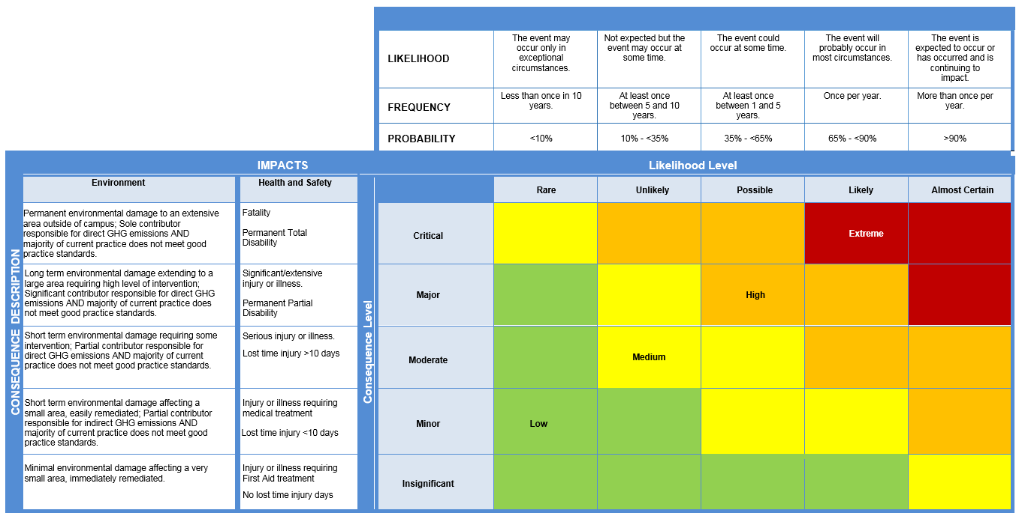
Health and Safety Risk Matrix

Determine the Risk Rating (Level of Risk)
- Select the Likelihood - Select the appropriate Likelihood or Frequency rating of the Risk Event occurring for the selected Consequence level, given the controls are in place.
- Select the Consequence - For the given Risk Event select the relevant Consequence categories and apply a rating. The ratings are determined with the existing controls in place. Where there are multiple ratings for a risk, the highest combination of Consequence/Likelihood is taken as the final risk rating (do not average out the ratings).
There are 3 types of risk ratings:
Inherent - no controls in place or total control failure; Current - with existing controls in place; Residual - with proposed treatment action plans (TAPs) in place.
Curtin requires the Current risk rating (as a minimum).

Risk Acceptance Criteria Table
Make an acceptance decision. Based on the current risk rating, use the Risk Acceptance Criteria Table to determine an appropriate decision and response
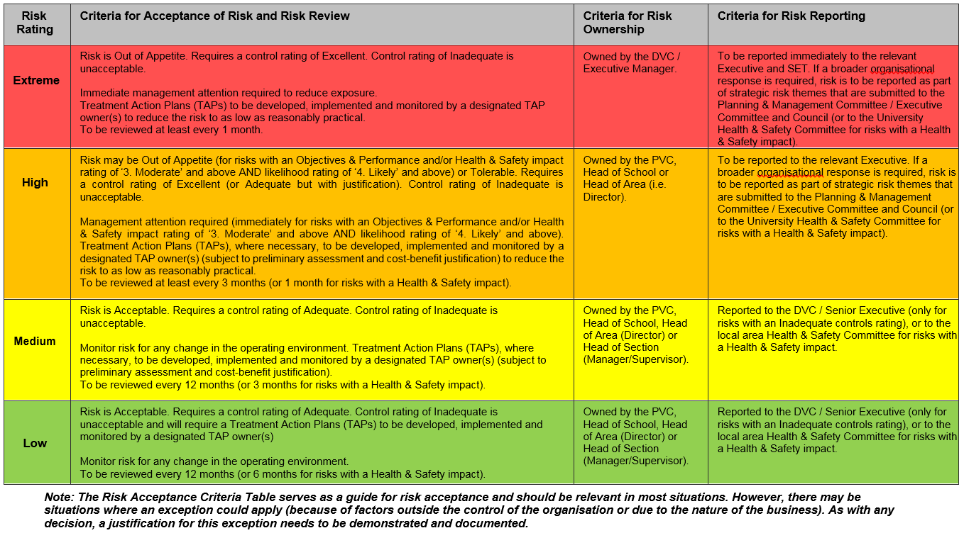

Controls Rating Table

Select the Overall Controls Rating (for ALL controls as a whole)
- Controls - A control is any measure or action currently in existence that modifies or manages the risk. Examples of controls could include a policy, procedure, practice, process, technology, technique, method, or device. A control should be demonstrable, i.e. auditable.
- Treatment Action Plans (TAPs) - TAPs are additional controls, where required. It could be an improvement of an existing control and/or a new initiative altogether. TAPs become controls, or modify existing controls, once they have been implemented.
The adequacy of the controls is assessed on a common sense, qualitative basis. This can be viewed as a reasonableness test, i.e. are you doing what is reasonable under the circumstances to prevent or minimise the impacts of the risk?

Level | Descriptor | Foreseeable | Detail
E | Excellent | More than what a reasonable person would be expected to do in the circumstances. | Controls fully in place and require only ongoing maintenance and monitoring. Protection systems are being continuously reviewed and procedures are regularly tested.
A | Adequate | Only what a reasonable person would be expected to do in the circumstances. | Being addressed reasonably. Protection systems are in place and procedures exist for common or typical circumstances. Periodic review.
I | Inadequate | Less than what a reasonable person would be expected to do in the circumstances. | Little to no action being taken. No protection systems exist or they have not been reviewed for some time. No formalised procedures.

Once the Overall Controls Rating (above) has been conducted on ALL controls as a whole, a Controls Assurance should be conducted on EACH control to determine if the controls are in place and effective.

Controls Assurance Questions:
- Is the control in use?  - Is the control documented?  - Is the control up to date?  - Is the control effective? | If you answered ‘Yes’ to all 4 questions, the control is effective (the control text should be Green).
 | If you answered ‘Yes’ to 2 or 3 questions, the control may require some improvements (the control text should be Blue).
 | If you answered ‘Yes’ to 1 or less questions, the control may require significant improvements (the control text should be Red).

This risk assessment has been developed through consultation with our employees and has been read, understood and signed by all employees undertaking the works
Print Names: | Signatures: Position: | Dates:

Review No | 01 | 02 | 03 | 04 | 05 | 06 | 07 | 08 | 09
Initial:
Date:

