HSEM assistance with the RA process is available. Please allow a 5 day turnaround for feedback
Risk Assessment Name: Collection or use of Hazardous Substances/Dangerous Goods/Medicine/Poison/Infectious Agents during fieldwork Risk Assessment

Risk Assessment Description: |  | Location/Date:
Risk Assessment Owner (Person developing RA)  Name:………………………………………………………………………..  Position:……………………………………………………………………..  Signature:……………………………………………………………………  Date: / /20 | Risk Assessment Approver (Person authorising RA)  Name:………………………………………………………………………..  Position:……………………………………………………………………..  Signature:……………………………………………………………………  Date: / /20
Documentation: Certificates, Permits, relevant Australian Standards and other documents applicable to this activity

IDENTIFY | ASSESS |  |  |  | CONTROL
Step 1  Enter risk description | Step 2  Select hierarchy of control and describe the existing control | Step 3  Level of risk with existing controls |  |  | Step 4  Select hierarchy of control and describe your proposed treatment | Step 5  Who is responsible and due date |  | Step 6  Level of risk after treatment
Risk Description (Hazard) | Existing Controls  Hierarchy of Control  - Eliminate, eg: eliminate task, remove hazard  - Substitute eg: replace with less hazardous process  - Isolate eg: enclosures, restricted access  - Engineering eg: guarding, separation, redesign  - Administrative eg: SWP, training, schedule  - Personal Protective Equipment (PPE) eg: gloves | Consequence | Likelihood | Risk Score | New/Additional Controls  Select the hierarchy of control and describe your proposed treatment | Who is responsible for implementing the control(s) | Due Date | Consequence | Likelihood | Risk Score
Hazards associated with preparing the substance/s for use in the field |  |  |  |  | Substance to be prepared inside a fume cabinet  Substance to be diluted down to suitable strength prior to transport and use in the field  Gloves required to be worn  Safety glasses required to be worn  Laboratory coat required to be worn  Eyewash station and safety shower available in the preparation laboratory  Sample/substance to be correctly labelled.
Hazards associated with transporting the substance/s to and from the field  Cylinders  Storage of substance on site |  |  |  |  | Chemicals are not to be transported in private vehicles  SDS available in vehicle being used.  Substance correctly diluted prior to transport  Substance to be double bagged prior to transport  Substance to be transported in a bund if possible  Substance to be sealed inside a box/esky prior to transport  Substance to be kept at the required temperature at all times  Powders and liquids to be transported in vehicle boot  Gas cylinders to be transported in an appropriately secured cage or using straps or chock blocks  Regulators have been removed prior to transport of the cylinders  Toxic cylinders are capped or plugged if possible.  Substances/chemicals are securely stored on site, restricted access where necessary..  Substance to be transported in specially licensed & placarded vehicle at all times  Register of Chemicals/substances being transported
Hazards associated with using the substance/s in the field |  |  |  |  | Gloves required to be worn  Safety glasses required to be worn  Laboratory coat required to be worn  Safety boots required to be worn  Mobile eye wash station available on site  Shower available on site  Spills/leaks procedure available  If decanting/mixing, this is to be done in a bund, away from water ways.
Hazards associated with collecting the substance/s on site |  |  |  |  | Suitable mask or respirator with correct classification of cartridge to be worn while collecting the substance  Suitable gloves to be worn  Spills/leaks procedure available  If decanting/mixing, this is to be done in a bund, away from water ways.  If there is a risk of infection from the samples suitable vaccines etc to be in place
Hazards associated with disposal of the substance/s |  |  |  |  | Appropriate Waste Container to be used (No food containers)  Substance to be clearly labelled “Waste”  Container to be kept sealed and disposed of intact through chemical disposal process  Substance to be transported back to campus for disposal  All biological waste to be autoclaved on return to campus  Chemical waste to be disposed by chemical contractor
SDS, Licenses and or permits to collect and or use the substance are not in place |  |  |  |  | All permits received prior to commencement of the trip  Copies of permits taken with participants on the trip  Contracts or agreements with external organisations are executed prior to approvals for the trip being provided
Risks to the environment through spilling/uncontrolled release the substance |  |  |  |  | Suitable spill kit taken to site for use as required  Fresh Water available for flushing if required  Clean equipment/tools used to prevent contamination.  Substance only to be collected in wind free situations
Manual Handling Risks – will we include this on the Hazardous materials RA? |  |  |  |  | Proper manual handling techniques used when handling substances (Cylinders for example)
Are you working with any substances that would require exposure monitoring? If so: |  |  |  |  | Monitoring devices to be made available e.g gas detectors, radiation badge etc
Will you be working with human patients in a clinical setting? |  |  |  |  | Follow  https://www.safeworkaustralia.gov.au/system/files/documents/1702/nationalcodeofpractice_control_workrelatedexposure_hepatitis_hivviruses_nohsc2010-2003_pdf.pdf  Ensure that appropriate immunisations as listed in the current Australian Immunisation Handbook, have been completed)  https://beta.health.gov.au/health-topics/immunisation/health-professionals .
Will you be performing research involving human participants? |  |  |  |  | Seek and gain approval from the Human Research Ethics Committee.
Will you be working with animal participants? |  |  |  |  | Seek and gain approval from the Animal Ethics Committee.
Will you be collecting animals, samples from animals or material discarded by animals?  (e.g. fish, vertebrates, insects, invertebrates, fur, skulls, feathers, carcasses, bones, scats) |  |  |  |  | Seek and gain permission to enter and sample from land - Landgate, Main Roads WA or the owner.  Wear PPE including gloves, eye protection and breathing protection until your sample has been contained, and wash your hands before touching your face or eating.  Vaccination if available.  For collecting native animals or their parts then you will need a fauna licence http://www.dpaw.wa.gov.au/plants-and-animals/licences-and-permits/134-fauna-forms or a fish licence http://www.fish.wa.gov.au/Pages/Home.aspx .  Transport the samples double contained and labelled.  If collecting into alcohol, other preservative, or into cryogenic refrigerant then manage those chemical hazards.
Will you be collecting native plants? |  |  |  |  | Seek and gain a flora licence http://www.dpaw.wa.gov.au/plants-and-animals/licences-and-permits/135-flora-licences .
Will you be collecting fungi or other microorganisms? |  |  |  |  | Seek and gain permission to enter and sample from land - Landgate, Main Roads WA or the owner.  Wear PPE including gloves, eye protection and breathing protection until your sample has been contained, and wash your hands before touching your face or eating.  Vaccination if available.  Transport the samples double contained and labelled.
Will you be collecting soil or water samples from WA? |  |  |  |  | Seek and gain permission to enter and sample from land - Landgate, Main Roads WA or the owner.  Wear PPE including gloves, eye protection and breathing protection until your sample has been contained, and wash your hands before touching your face or eating.  Vaccination if available.  Transport the samples double contained and labelled.
Will you be collecting samples of/from soil, water, animals, or plants interstate or overseas for importation into WA? |  |  |  |  | Work within the State and Federal biosecurity regulatory system, to seek appropriate Import Permits, and to follow the Import Conditions on the Import Permit.  Transport the samples following the International Air Transport Authority (IATA) Dangerous Goods Regulations for Category 6.
Will you be leaving Australia and taking with you any goods on the Defence and Strategic Goods List? |  |  |  |  | Perform a DSGL self-assessment and seeking any required Export Controls.
Will you be collecting or transporting samples that fall under the Convention on International Trade in Endangered Species of Wild Fauna and Flora (CITES)? |  |  |  |  | Seek and gain a CITES Permit.
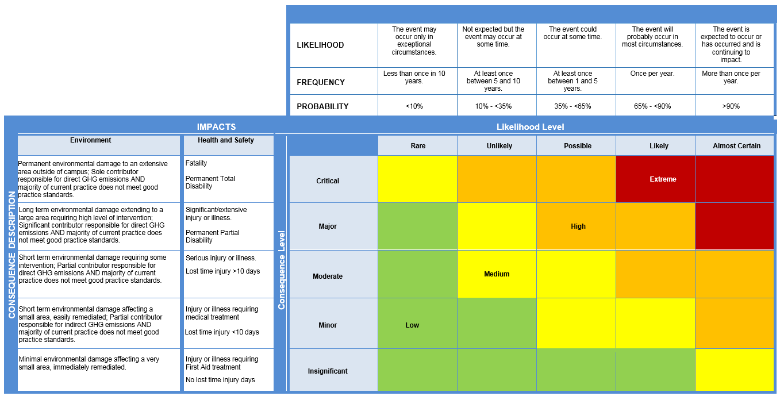
Health and Safety Risk Matrix

Determine the Risk Rating (Level of Risk)
- Select the Likelihood - Select the appropriate Likelihood or Frequency rating of the Risk Event occurring for the selected Consequence level, given the controls are in place.
- Select the Consequence - For the given Risk Event select the relevant Consequence categories and apply a rating. The ratings are determined with the existing controls in place. Where there are multiple ratings for a risk, the highest combination of Consequence/Likelihood is taken as the final risk rating (do not average out the ratings).
There are 3 types of risk ratings:
Inherent - no controls in place or total control failure; Current - with existing controls in place; Residual - with proposed treatment action plans (TAPs) in place.
Curtin requires the Current risk rating (as a minimum).

Risk Acceptance Criteria Table
Make an acceptance decision. Based on the current risk rating, use the Risk Acceptance Criteria Table to determine an appropriate decision and response
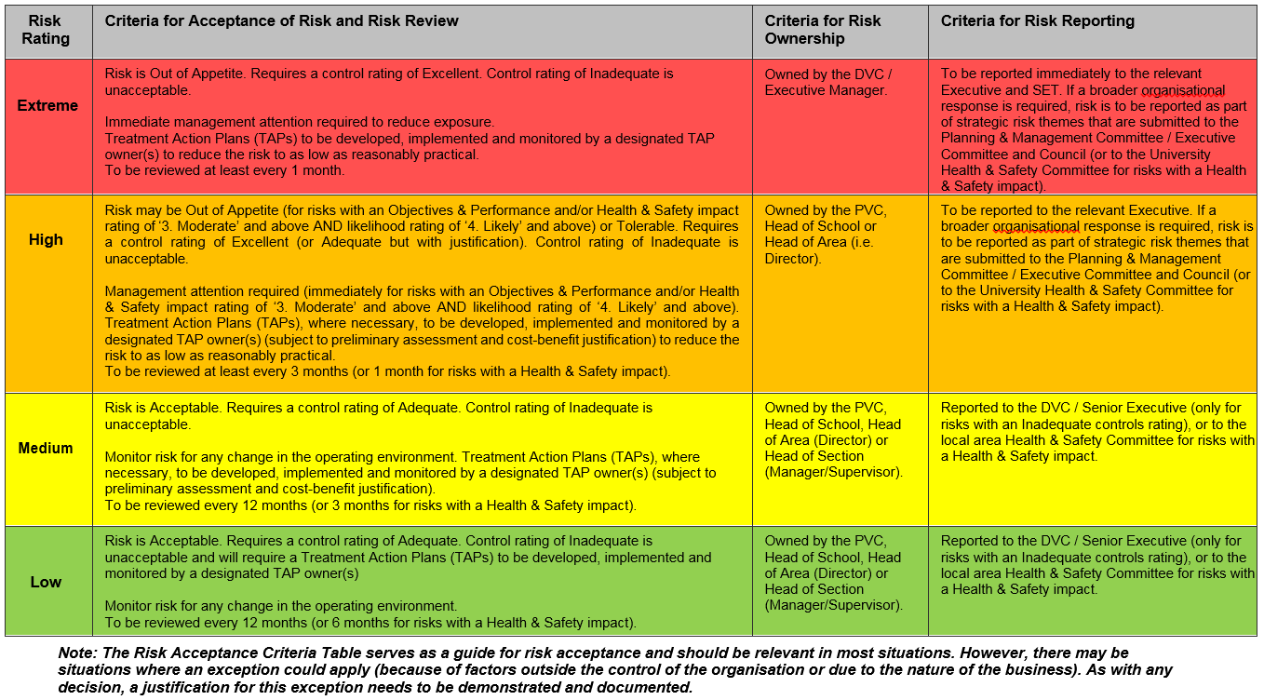

Controls Rating Table

Select the Overall Controls Rating (for ALL controls as a whole)
- Controls - A control is any measure or action currently in existence that modifies or manages the risk. Examples of controls could include a policy, procedure, practice, process, technology, technique, method, or device. A control should be demonstrable, i.e. auditable.
- Treatment Action Plans (TAPs) - TAPs are additional controls, where required. It could be an improvement of an existing control and/or a new initiative altogether. TAPs become controls, or modify existing controls, once they have been implemented.
The adequacy of the controls is assessed on a common sense, qualitative basis. This can be viewed as a reasonableness test, i.e. are you doing what is reasonable under the circumstances to prevent or minimise the impacts of the risk?

Level | Descriptor | Foreseeable | Detail
E | Excellent | More than what a reasonable person would be expected to do in the circumstances. | Controls fully in place and require only ongoing maintenance and monitoring. Protection systems are being continuously reviewed and procedures are regularly tested.
A | Adequate | Only what a reasonable person would be expected to do in the circumstances. | Being addressed reasonably. Protection systems are in place and procedures exist for common or typical circumstances. Periodic review.
I | Inadequate | Less than what a reasonable person would be expected to do in the circumstances. | Little to no action being taken. No protection systems exist or they have not been reviewed for some time. No formalised procedures.

Once the Overall Controls Rating (above) has been conducted on ALL controls as a whole, a Controls Assurance should be conducted on EACH control to determine if the controls are in place and effective.

Controls Assurance Questions:
- Is the control in use?  - Is the control documented?  - Is the control up to date?  - Is the control effective? | If you answered ‘Yes’ to all 4 questions, the control is effective (the control text should be Green).
 | If you answered ‘Yes’ to 2 or 3 questions, the control may require some improvements (the control text should be Blue).
 | If you answered ‘Yes’ to 1 or less questions, the control may require significant improvements (the control text should be Red).

This risk assessment has been developed through consultation with our employees and has been read, understood and signed by all employees undertaking the works
Print Names: | Signatures: Position: | Dates:

Review No | 01 | 02 | 03 | 04 | 05 | 06 | 07 | 08 | 09
Initial:
Date:

