Guidelines for transporting biological materials by post, plane, car, truck, bus or train.

You might need to transport biohazards (experiments or waste) by post or by plane, or from one campus to another by car, truck, bus or train.

You will need to package and label your samples to ensure that, no matter what happens to the package during transport, they will not:
• become contaminated by the environment
• escape containment to contaminate people or the environment.

If you are transporting material that is infectious towards humans or animals then it is classified as a Dangerous Good Class 6.2. Similarly, if you are transporting material that could contain microorganisms that could be infectious towards humans or animals (such as blood samples from unknown donors) then it is also classified as a Dangerous Good Class 6.2.

Transporting biological materials by post, plane, or land vehicle is a regulated activity, and you must do it following these regulations, that are summarised in these Guidelines:
- The IATA Dangerous Goods Regulations.
- The Australia Post, Dangerous and Prohibited Goods and Packaging Guide.
- Australian Code for the Transport of Dangerous Goods by Road and Rail.
- The International Maritime Organization (IMO), International Maritime Dangerous Goods Code (IMDG Code).
- The Office of the Gene Technology Regulator (OGTR), Guidelines for the transport of GMOs.
- United Nations Recommendations on the Transport of Dangerous Goods. Model Regulations.

When transporting by post, plane, car, truck, bus or train, the requirements for packaging and labelling are different depending on what biological materials you are transporting.

Section 14 of the AS/NZS 2243.3:2022 describes this in detail. Staff and Students can access Australian Standards through Curtin Library’s TechStreet account.

Category A biological material - Dangerous Good Class 6.2 | - Infectious substances which are capable of causing permanent disability, or a life-threatening or fatal disease, to otherwise healthy humans or animals.  - Infectious agents of plants that could cause significant damage to the environment or agriculture are included in this category.
Category B biological material - Dangerous Good Class 6.2 | - Infectious substances that do not meet the criteria for Category A.  - Samples with unknown infectious status.
Category C biological material - Not a dangerous good | - Substances with a low probability of causing disease in humans, animals or plants.  - Samples from healthy plants.  - Samples from healthy humans and animals including excreta, secreta, blood and its components, tissues and tissue fluids.

The diagram below, from A/NZS2243.3:2022, shows the packing and labelling requirements for Categories A and B biological material.

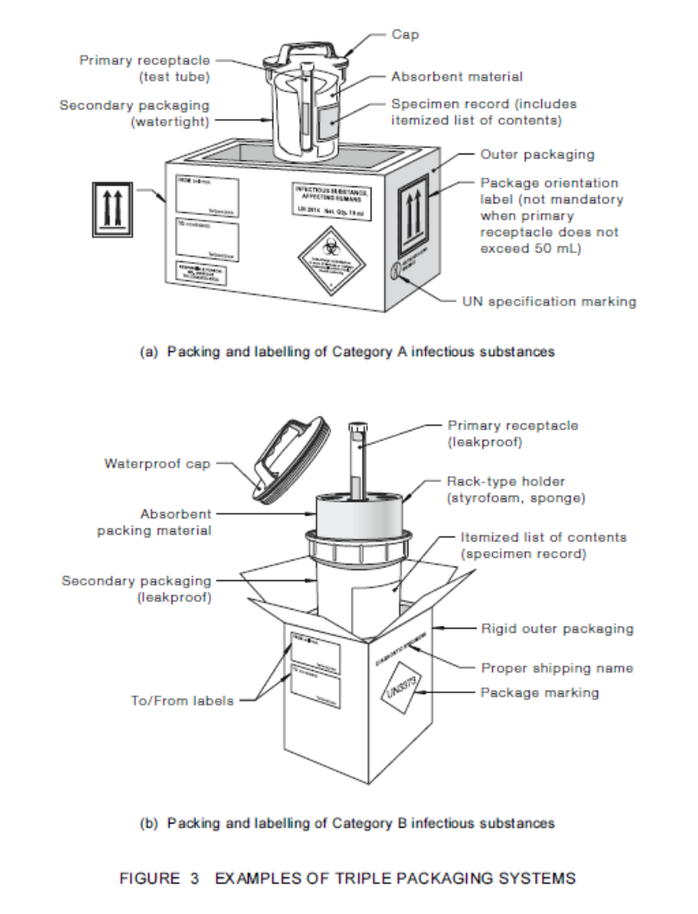

You must be trained to pack Dangerous Goods for air transport.

In Australia, Item 92.120 of the Civil Aviation Safety Regulations specifies required training for packing dangerous goods for transport by air. All persons who pack dangerous goods for transport by air (including enclosing the goods in packaging, marking or labelling the consignment or preparing a shipper’s declaration) are required to successfully complete a course approved by the Civil Aviation Safety Authority, Australia.

The IATA Dangerous Goods Regulations define the requirements for certification, packing instructions, the maximum quantities that can be transported by cargo or passenger aircraft, the external labelling requirements (including the identifying UN number), and the details to be included in the attached Shippers Declaration for Dangerous Goods.

CATEGORY C
When transporting Category C biological materials that do not contain microorganisms infectious to humans or animals, then you just need to double contain your samples to withstand the conditions of the journey.

These will include variations in temperature and air pressure, plus the physical rigours of being crushed under other items in the cargo hold of the plane. In the picture above, you can see features of packaging including multiple layers of sealed and rigid containers, padding and bunding between the layers, and labelling to identify the contents – all of these features will be needed for your packaging.

Australia Post or a courier company can help you to pack your materials to survive the journey. Always use packing materials designed for the purpose. Always fill in all the information that is asked for on the outer labels of the packaging – if you leave any of it blank than your package may seem suspicious and be stopped by the security systems of the post office or airport.

REFRIGERANTS
- Use freezer bricks rather than wet ice.
- If you want to refrigerate your package using dry ice (carbon dioxide) or liquid nitrogen then those are Dangerous Goods and have their own safe handling practices and regulatory requirements that are not covered in this course. Avoid using these refrigerants, but if you need to then you need to find out how to do so safely.

HIGHER CONTAINMENT CONSIDERATIONS
Biological materials such as genetically modified organisms (GMOs), quarantined materials, and live animals have their own transport requirements that also need to be fulfilled. If you want to use these materials then please do the training specific for those materials.

OTHER CONSIDERATIONS

- Before you send a biological sample, you must advise the recipient to expect it.
- If you ask someone to send you a biological sample, then it is your responsibility to tell the sender to pack the sample following the regulations in this Guideline.
- Biological samples entering Australia will be subject to quarantine – you can find out information about quarantine on the Curtin Biosafety webpages.
- Unpack packages carefully, and in a biosafety cabinet if necessary, in case the containers have broken during transport.

