Furniture Hazard - Loose Pinboard
Who needs to read this?
All Curtin University Staff and Contractors
Information
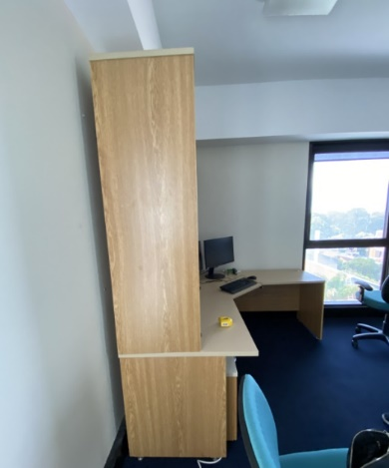
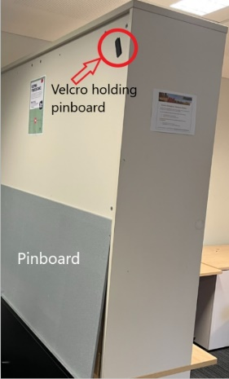
During relocation of an L-shaped desk, a pinboard attached to the back of the hutch came loose and fell, causing serious hand injuries (including fractures to three fingers).
Key Message
When working around desks, particularly underneath them for tasks like connecting power/data cables, be cautious as the pinboard may be loose. If you need to move or relocate your desk, please raise a Maintenance request.
If you suspect that the pinboard in your work area is loose, or presents a safety hazard:
- Report it to the School Business Manager.
- School Business Manager will collate the reported issues in the Desk Hutch Audit Checklist.
- School Business Manager will email Interiors and Minor Projects via interiorsoffice@curtin.edu.au for the consolidated requests.
- Interiors and Minor Projects will engage Contractor and coordinate the process of securing / disposing of pinboards.
Who do you call with questions?
If you have any queries, please contact Health and Safety on 9266 4900 or email healthandsafety@curtin.edu.au.
Date of Issue
14/09/2023

