For everyone’s safety, work safely. #SafeWorkMonth
Who needs to read this?
All Curtin Staff – especially Health and Safety Representatives and Mental Health First Aiders.
Background
Welcome to the second week of National SafeWork Month. This week’s focus is “Working together to protect worker’s mental health.”
Information
There are a range of psychosocial hazards that impact worker mental health. WorkSafe has released the Code of Practice – Psychosocial hazards in the workplace, and Safe Work Australia and Health and Safety provide information and resources on to assist managers and staff.
Key Messages
The management of psychosocial hazards is key to the prevention of these types of injuries. If you are a manager or supervisor of staff or students, you have a responsibility to ensure that these hazards are identified; if present and suitably controlled.
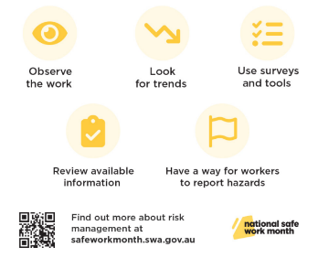
- If you are unsure how to risk assess psychosocial hazards,
please contact Health and Safety.
- Our EAP - Assure - also have a Manager Support Program available to
assist managers to support their staff should they report a
psychosocial hazard. (see attached flier)
- All staff are invited to join the Curtin specific Headspace
webinar on Friday 13 October. (see attached flier)
Who do you call with questions?
If you have any queries, please contact Employee Wellbeing on 9266 4468 or Health and Safety on 9266 4900 or email healthandsafety@curtin.edu.au.
References
Safe Work Australia – Psychosocial hazards
Worksafe WA –Mentally healthy workplaces – Podcasts and videos
Date of Issue
10/10/2023

