Risk Assessment Name:
Risk Assessment Description: | Location/Date:

Describe the working environment including layout and physical conditions:

Risk Assessment factors and considerations: | Other considerations:

What reference materials were used when developing this risk assessment? For example:
- Legislation | - Standard operating procedures
- Code of practice | - Incident investigations
- Australian standards | - Manufacturer’s instructions

Who was involved in the development of this risk assessment?
Owner: Signature: Date:
Approver Signature Date:

IDENTIFY | ASSESS |  |  |  | CONTROL
Step 1  Enter risk description | Step 2  Select hierarchy of control and describe the existing control | Step 3  Level of risk with existing controls |  |  | Step 4  Select hierarchy of control and describe your proposed treatment | Step 5  Who is responsible and due date | Step 6  Level of risk after treatment
Risk Description (Hazard) | Existing Controls  Hierarchy of Control  - Eliminate, eg: eliminate task, remove hazard  - Substitute eg: replace with less hazardous process  - Isolate eg: enclosures, restricted access  - Engineering eg: guarding, separation, redesign  - Administrative eg: SWP, training, schedule  - Personal Protective Equipment (PPE) eg: gloves | Consequence | Likelihood | Risk Score | New/Additional Controls  Select the hierarchy of control and describe your proposed treatment | Who is responsible for implementing the control(s) & Due date | Consequence | Likelihood | Risk Score
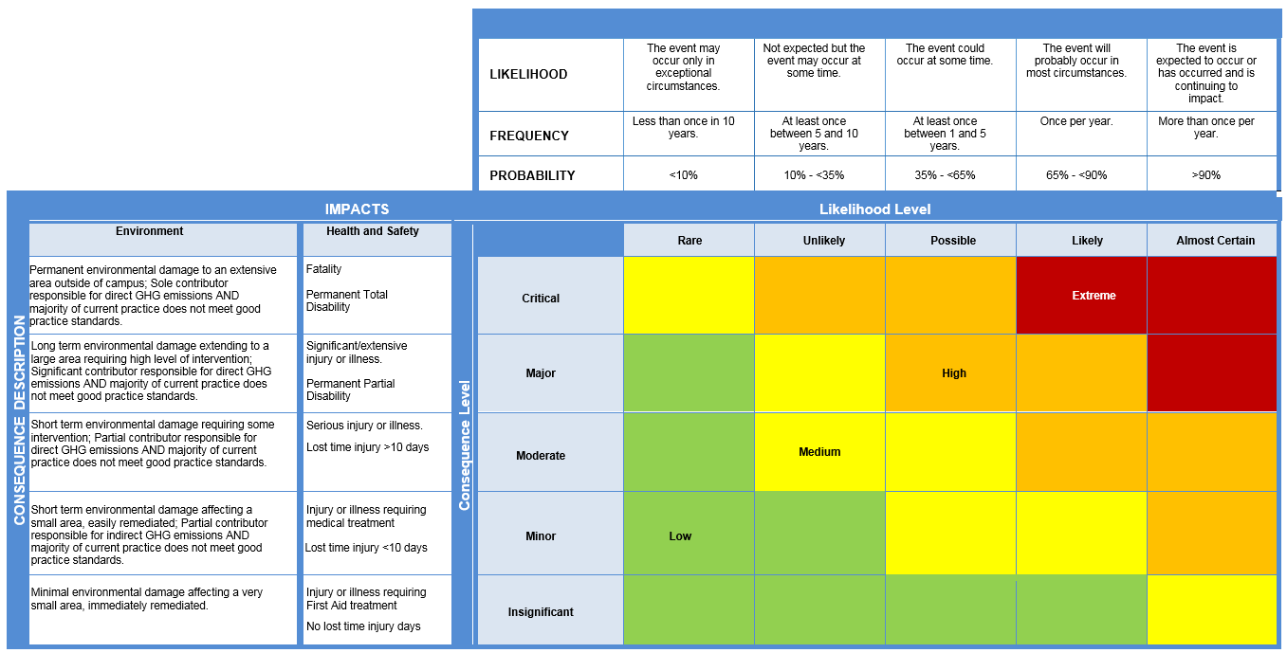
Health and Safety Risk Matrix

Determine the Risk Rating (Level of Risk)
- Select the Likelihood - Select the appropriate Likelihood or Frequency rating of the Risk Event occurring for the selected Consequence level, given the controls are in place.
- Select the Consequence - For the given Risk Event select the relevant Consequence categories and apply a rating. The ratings are determined with the existing controls in place. Where there are multiple ratings for a risk, the highest combination of Consequence/Likelihood is taken as the final risk rating (do not average out the ratings).
There are 3 types of risk ratings:
Inherent - no controls in place or total control failure; Current - with existing controls in place; Residual - with proposed treatment action plans (TAPs) in place.
Curtin requires the Current risk rating (as a minimum).

Risk Acceptance Criteria Table
Make an acceptance decision. Based on the current risk rating, use the Risk Acceptance Criteria Table to determine an appropriate decision and response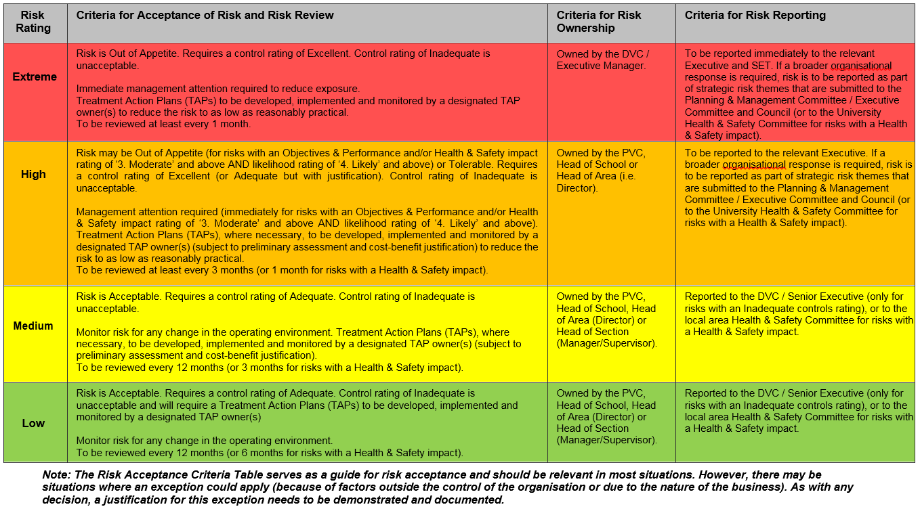

Controls Rating Table

Select the Overall Controls Rating (for ALL controls as a whole)
- Controls - A control is any measure or action currently in existence that modifies or manages the risk. Examples of controls could include a policy, procedure, practice, process, technology, technique, method, or device. A control should be demonstrable, i.e. auditable.
- Treatment Action Plans (TAPs) - TAPs are additional controls, where required. It could be an improvement of an existing control and/or a new initiative altogether. TAPs become controls, or modify existing controls, once they have been implemented.
The adequacy of the controls is assessed on a common sense, qualitative basis. This can be viewed as a reasonableness test, i.e. are you doing what is reasonable under the circumstances to prevent or minimise the impacts of the risk?

Level | Descriptor | Foreseeable | Detail
E | Excellent | More than what a reasonable person would be expected to do in the circumstances. | Controls fully in place and require only ongoing maintenance and monitoring. Protection systems are being continuously reviewed and procedures are regularly tested.
A | Adequate | Only what a reasonable person would be expected to do in the circumstances. | Being addressed reasonably. Protection systems are in place and procedures exist for common or typical circumstances. Periodic review.
I | Inadequate | Less than what a reasonable person would be expected to do in the circumstances. | Little to no action being taken. No protection systems exist or they have not been reviewed for some time. No formalised procedures.

Once the Overall Controls Rating (above) has been conducted on ALL controls as a whole, a Controls Assurance should be conducted on EACH control to determine if the controls are in place and effective.

Controls Assurance Questions:
- Is the control in use?  - Is the control documented?  - Is the control up to date?  - Is the control effective? | If you answered ‘Yes’ to all 4 questions, the control is effective (the control text should be Green).
 | If you answered ‘Yes’ to 2 or 3 questions, the control may require some improvements (the control text should be Blue).
 | If you answered ‘Yes’ to 1 or less questions, the control may require significant improvements (the control text should be Red).

This risk assessment has been developed through consultation with our workers and has been read, understood and signed by all workers undertaking the works
Print Names: | Signatures: Position: | Dates:

Review No | 01 | 02 | 03 | 04 | 05 | 06 | 07 | 08 | 09
Initial:
Date:

